*&---------------------------------------------------------------------*

*& Report ZST7_REDUCE_CAST_SAMPLE

*&---------------------------------------------------------------------*

*&

*&---------------------------------------------------------------------*

report zst7_reduce_sample.

include ZST7_REDUCE_CAST_SAMPLE_sel.

include ZST7_REDUCE_CAST_SAMPLE_frm.

start-of-selection.

perform get_display_data.

*&---------------------------------------------------------------------*

*& Include ZST7_REDUCE_CAST_SAMPLE_SEL

*&---------------------------------------------------------------------*

selection-screen begin of block b1 with frame title text-001.

data lv_kunnr type bsid-kunnr.

select-options : s_kunnr for lv_kunnr.

selection-screen end of block b1.

*&---------------------------------------------------------------------*

*& Include ZST7_REDUCE_CAST_SAMPLE_FRM

*&---------------------------------------------------------------------*

*&---------------------------------------------------------------------*

*& Form get_display_data

*&---------------------------------------------------------------------*

*& text

*&---------------------------------------------------------------------*

*& --> p1 text

*& <-- p2 text

*&---------------------------------------------------------------------*

form get_display_data .

select bukrs, kunnr, umsks, umskz, augdt, augbl, zuonr, gjahr,belnr, buzei,shkzg, blart,

case shkzg when 'H' then cast( dmbtr * -1 as curr( 13,2 ) ) else cast( dmbtr as curr( 13,2 ) ) end

as amount from bsid into table @data(gt_bsid)

where kunnr in @s_kunnr.

if gt_bsid is not initial.

select kunnr, cast( 0 as dec ) as amount from kna1 into table @data(gt_kna1) where kunnr in @s_kunnr.

loop at gt_kna1 assigning field-symbol(<fs1>).

<fs1>-amount = reduce i( init i type dmbtr for wa in gt_bsid where ( kunnr = <fs1>-kunnr ) next i = i + wa-amount ).

endloop.

endif.

break-point.

cl_demo_output=>write( gt_bsid ).

cl_demo_output=>write( gt_kna1 ).

cl_demo_output=>display( ).

endform.

FROM DEBUGGER BEFORE REDUCE:

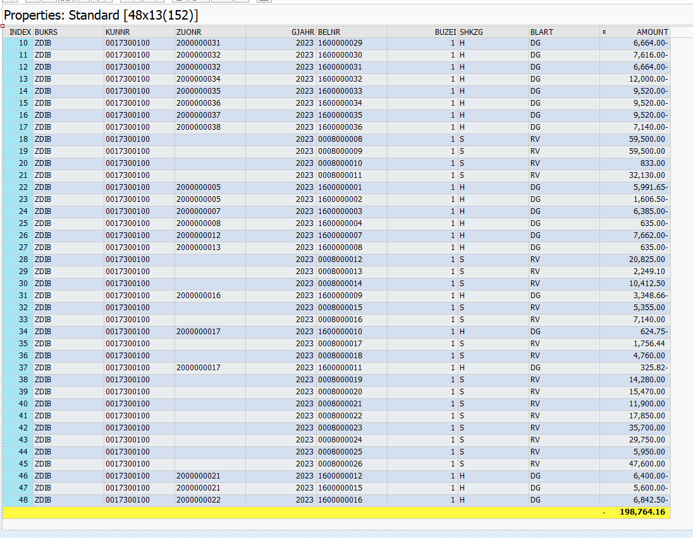

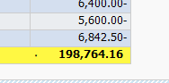

Program result displayed:

